[1] CSA-1557 CLOUD COMPUTING LAB PRACTICALS

3.Create a Virtual Hard Disk and allocate the storage using VM ware Workstation.

Step-1:

First install VMware workstation on your pc/laptop. Then open the VM software and click create a new virtual machine displayed on a home tab.

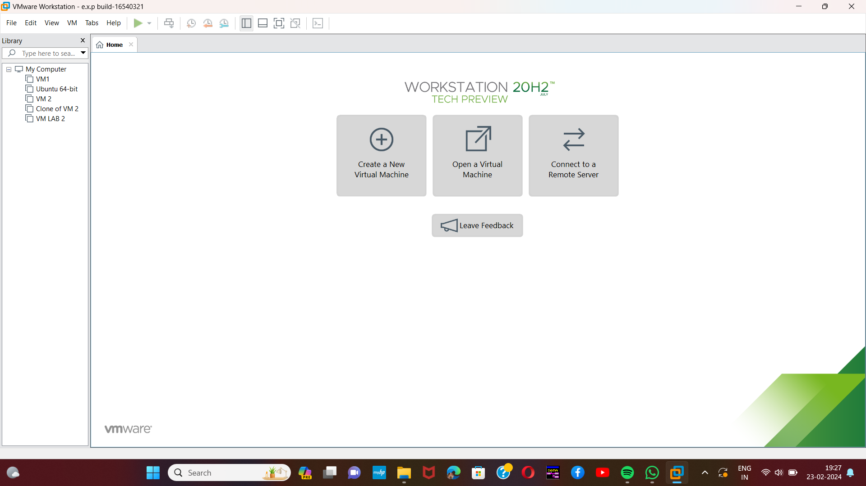

Step-2:

Then open any already created dummy Virtual Machine.

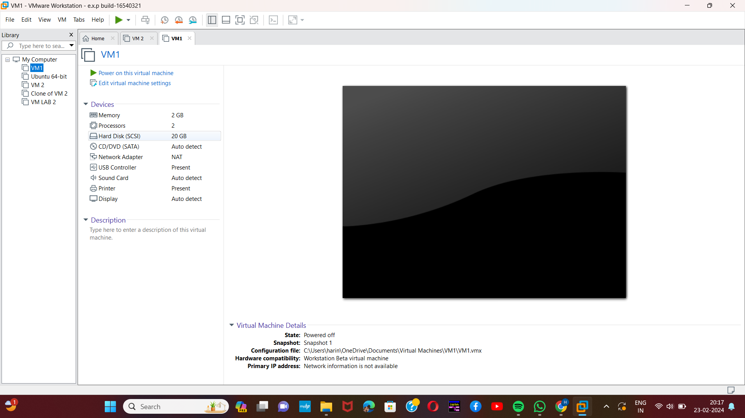[2]

Step-3:

Left side click any of the given specifications. Then click the Add option given below all the specifications.

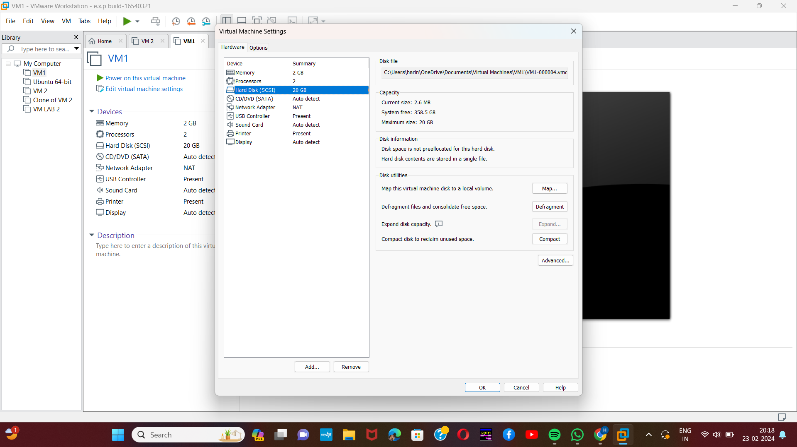

[3]Step-4:

Then click the hard disk option,because we are going to Create a Virtual Hard Disk and allocate the storage using a VM.

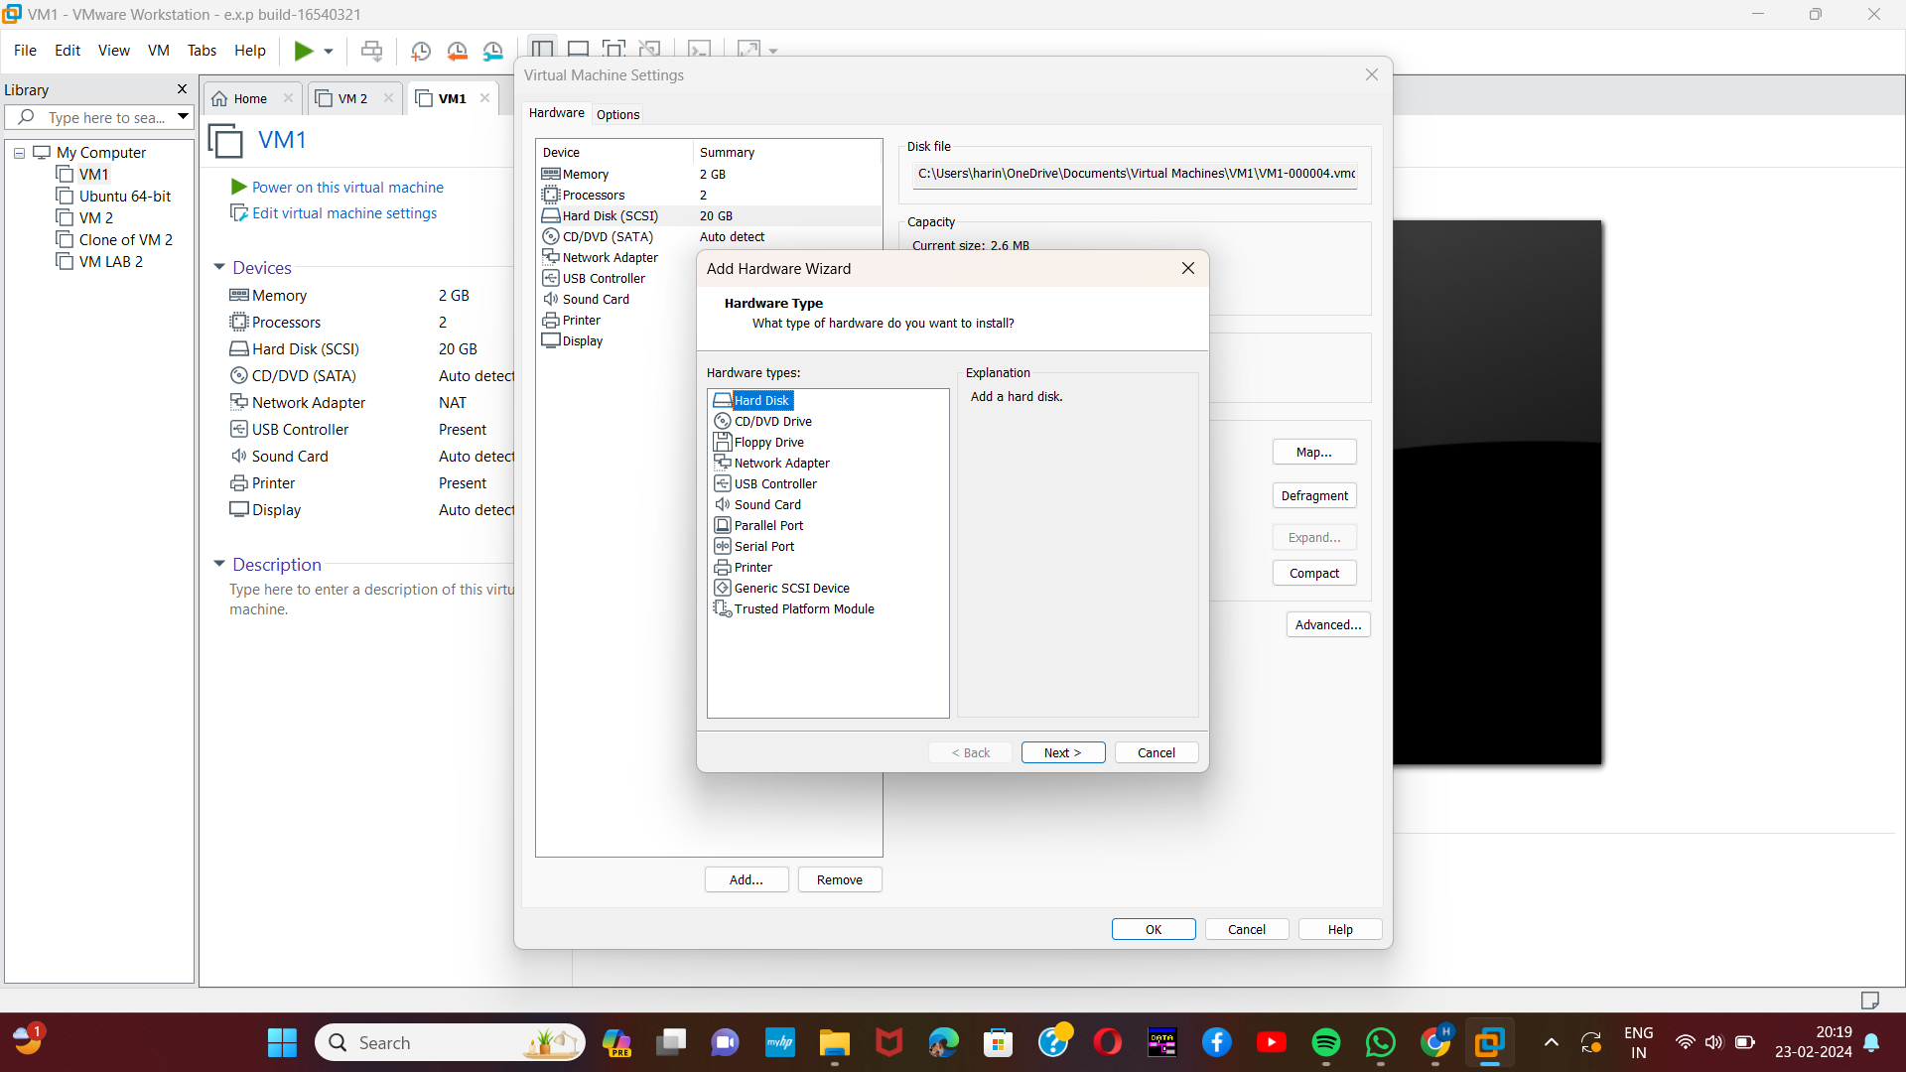

Step-5:

And select the SCSI option and click next.

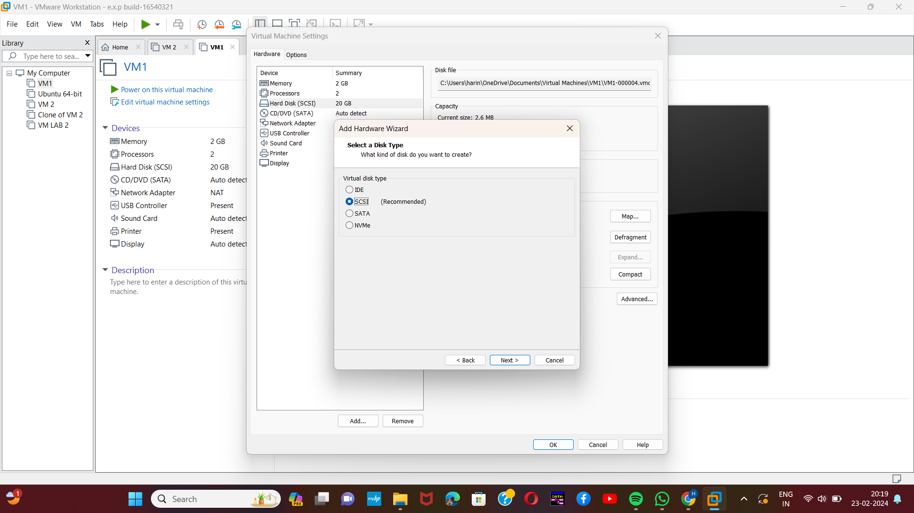

[4]Step-6:

Then select the first option from the displayed option.

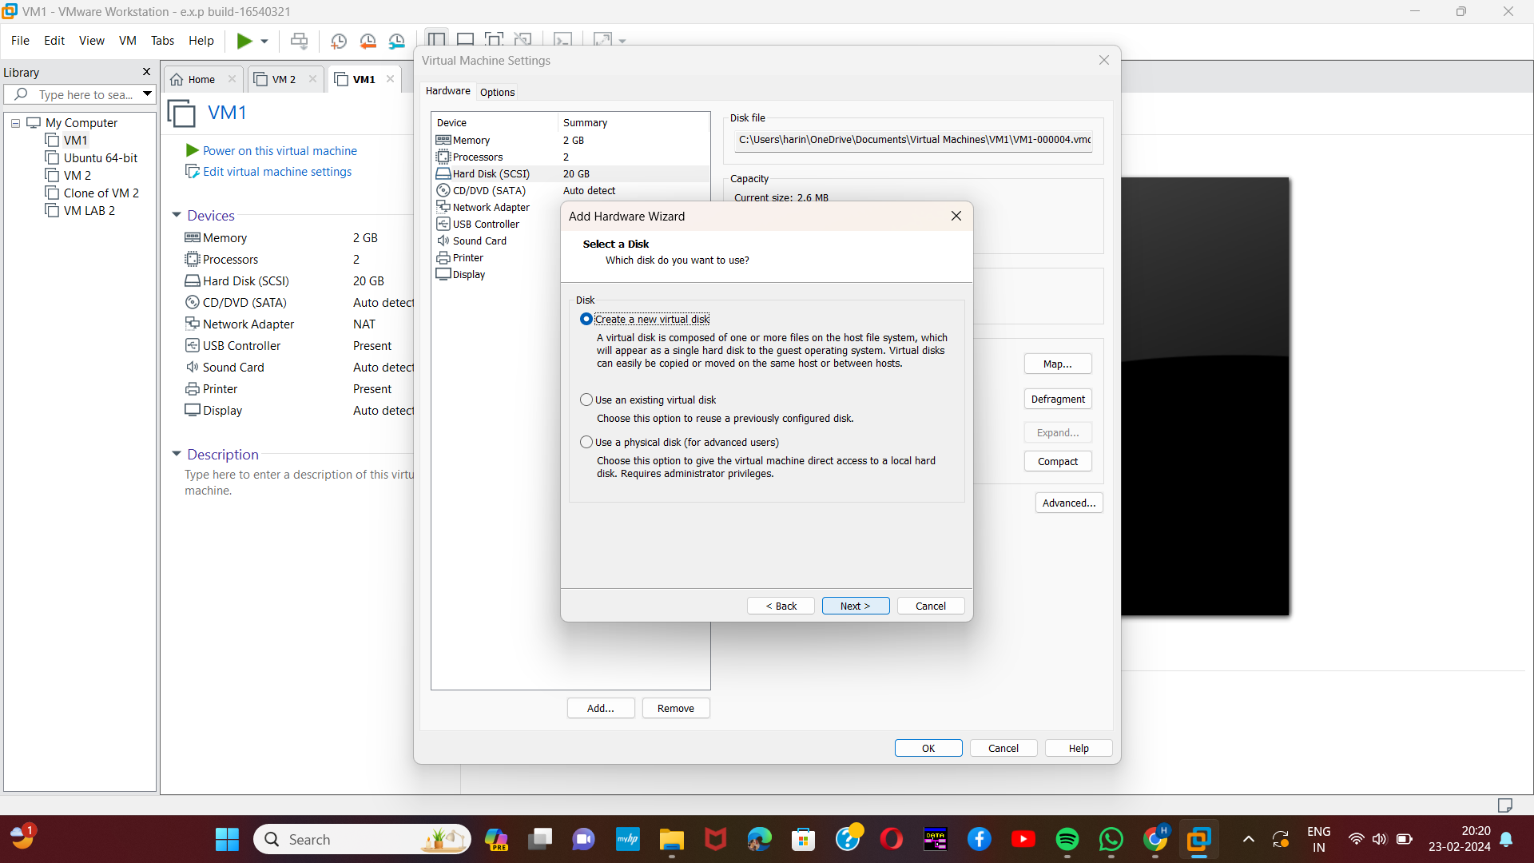

Step-7:

Then provide appropriate hard disk size.

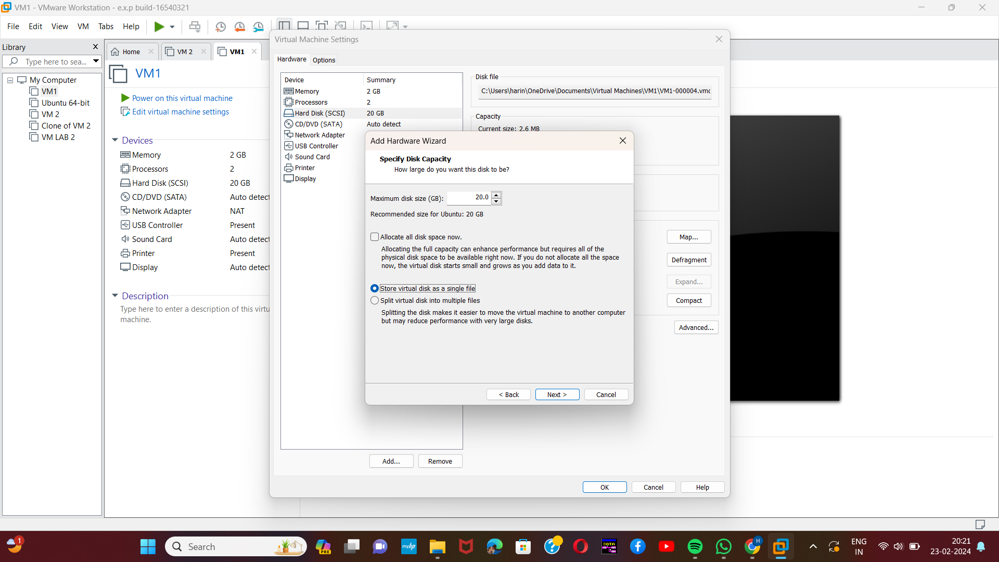

[5]Step-8:

Then give the appropriate name for the specific disk.

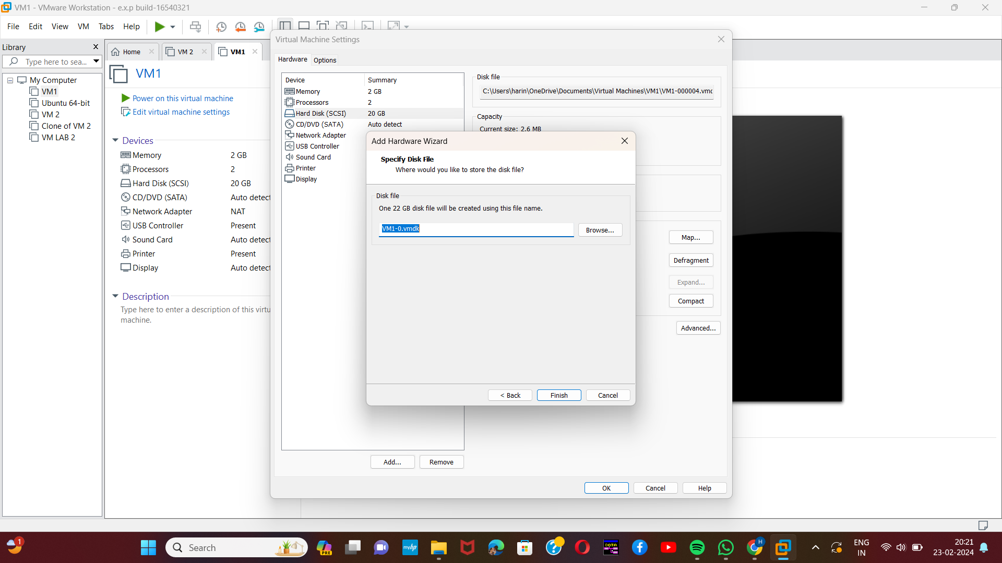

Step-9:

Our VM created a Virtual Hard Disk and allocated the storage using the VM.

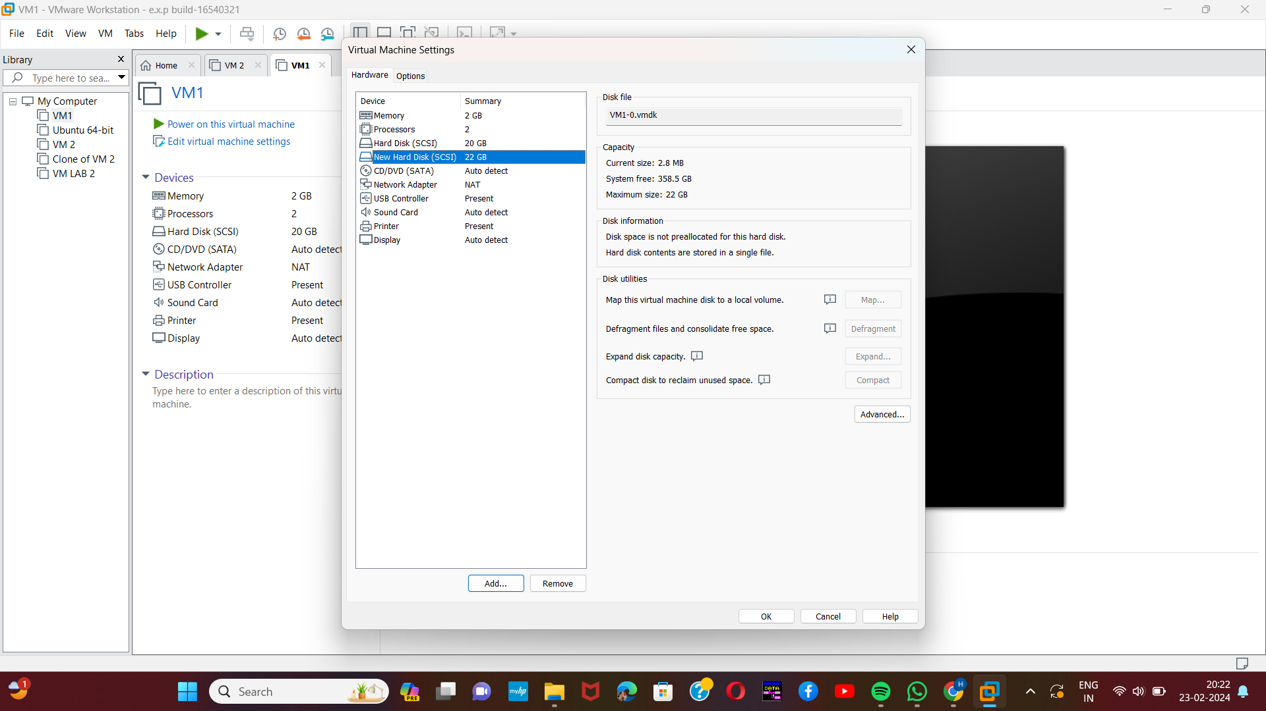

1. Harini 192221109
2. Harini 192221109
3. Harini 192221109
4. Harini 192221109
5. Harini 192221109